**Cloud Computing Practical**

Mahalaxmi Sarvai

Roll no: 37

**Practical 1**

1. Study and implementation of Infrastructure as a Service.

**Aim:** To study cloud architecture and cloud computing model.

**Objectives:** From this experiment, the student will be able

1. To provide an overview of concepts of Cloud Computing.
2. To encourage students to indulge into research in Cloud Computing.

**Outcomes:** The learner will be able to

* Understand and appreciate cloud architecture.
* Analyze the local and global impact of computing on individuals, organizations, and society.
* Recognize the need for, and an ability to engage in life-long

learning.

**Theory:**

Cloud computing enables companies to consume compute

resources as a utility -- just

Like electricity -- rather than having to build and maintain

computing infrastructures in-

House. Cloud computing promises several attractive benefits for

businesses and end Users.

Three of the main benefits of cloud computing include:

• **Self-service provisioning:** End users can spin up computing

resources for almost any

type of workload on-demand.

• **Elasticity:** Companies can scale up as computing needs increase

and then scale down again as demands decreases.

* **Pay per use:** Computing resources are measured at a granular

level, allowing users to pay only for the resources and workloads they use.

Cloud computing services can be Private, Public or Hybrid.

Private cloud services are delivered from a business data

center to internal users. This model offers versatility and

convenience, while preserving management, control and

security. Internal customers may or may not be billed for services through IT chargeback.

**Conclusion:**

Cloud computing enables a convenient and on-demand network

access to a wide range of resources. The different services and also

the deployment models allow flexible service provider interaction

with minimal human intervention. It saves costs but also can lead

to risk issues and suspension of resources when in huge quantity.

**Practical 3**

1. Study and implementation of Infrastructure as a Service

Infrastructure as a Service (IaaS) hosts infrastructure on the public cloud and private cloud instead of in a traditional on-premises data center. The infrastructure is delivered to customers on demand while being fully managed by the service provider.

**What is Infrastructure as a Service?**

Infrastructure as a Service (IaaS) is a cloud computing service, where enterprises rent or lease servers for compute and storage in the cloud.

Users can run any operating system or applications on the rented servers without the maintenance and operating costs of those servers.

Other advantages of Infrastructure as a Service include giving customers access to servers in geographic locations close to their end users.

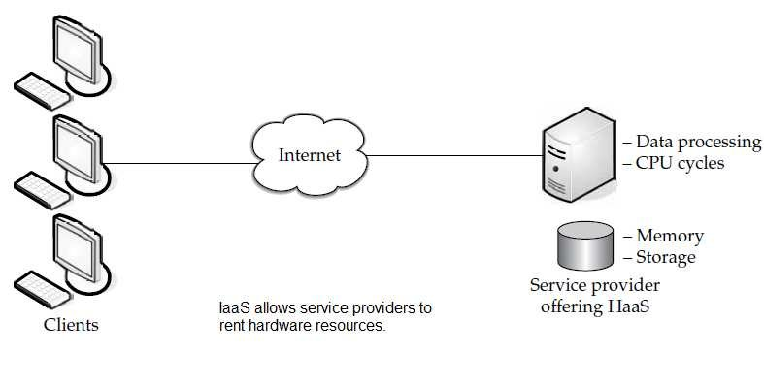

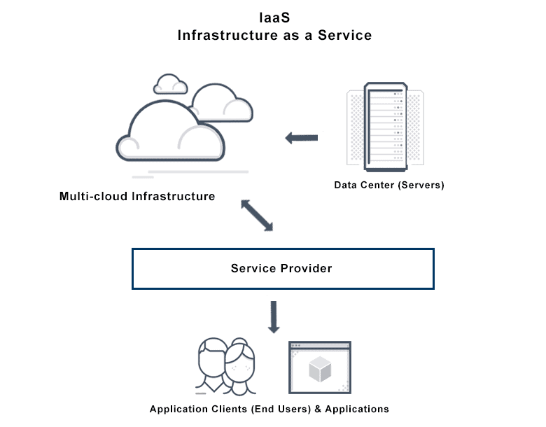

**What are the Benefits of Infrastructure-as-a-Service?**

Infrastructure as a Service (IaaS) can be more efficient for an enterprise than owning and managing its own infrastructure. New applications can be tested with an IaaS provider instead of acquiring the infrastructure for the test.

* Continuity and disaster recovery
* Faster scaling
* Core focus

**How to Implement Infrastructure as a Service?**

The implementation can be in a public, private or hybrid cloud

setting. Customers use a graphical interface to change the

infrastructure as needed. The infrastructure can also be accessed

through an API key — so new servers are brought online as part of an

automation when needed.

**Enterprises use IaaS to do the following more efficiently:**

* Test and development
* Backup and recovery
* Big data analysis

**Practical 4**

1. Study and implementation of Storage as a Service

**Step 1:** Open Google Drive

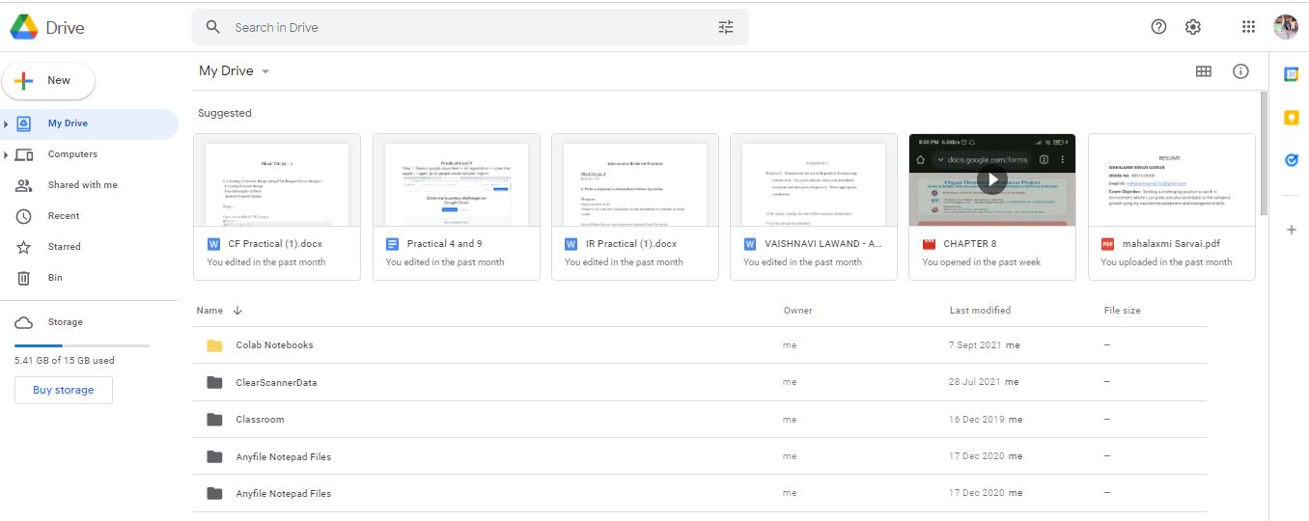

**Step 2:** And then Upload the Document

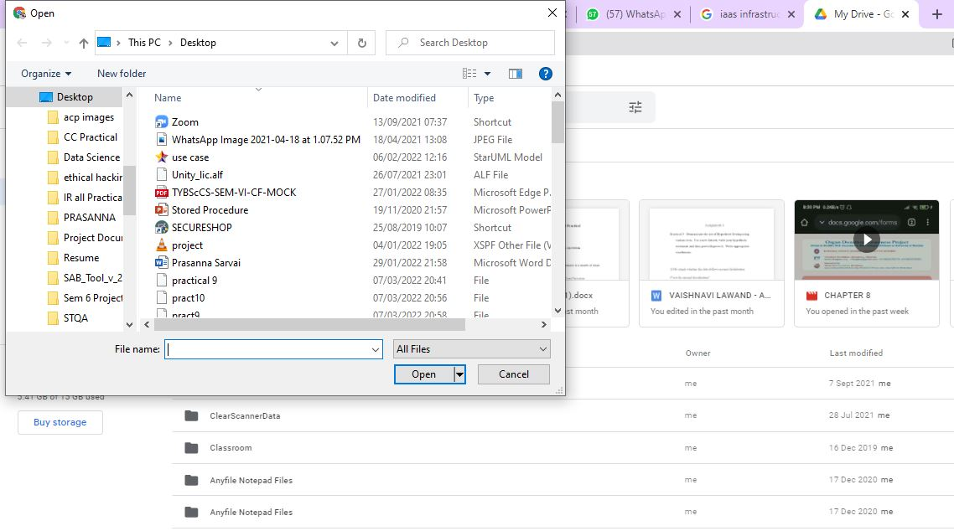

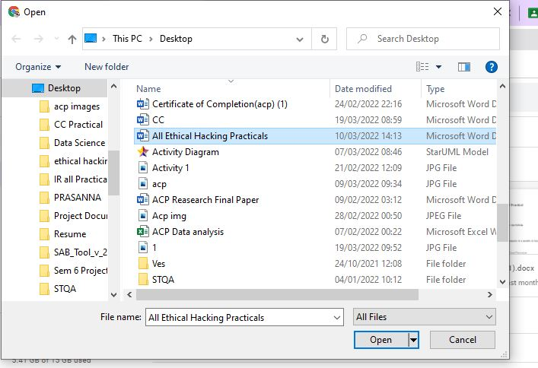

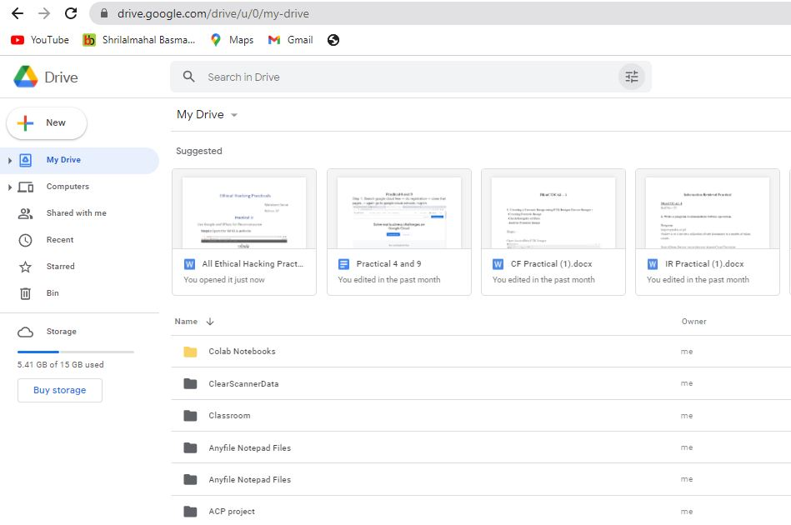

**Practical 5**

1. Study and implementation of identity management

Open Aws Management Console

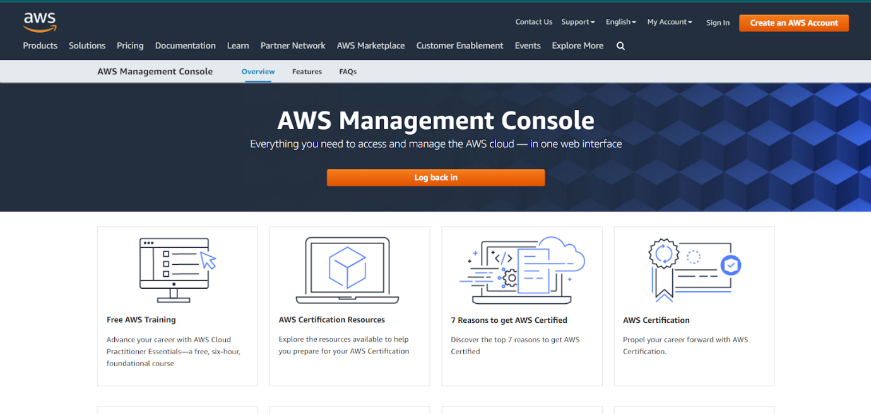

Then go to my account and then select account settings

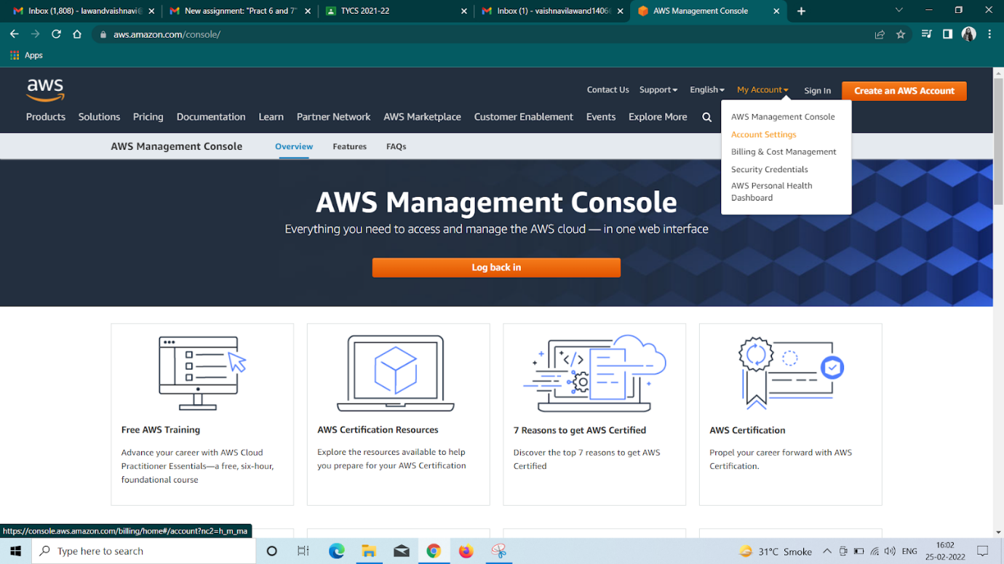

Then create a new AWS account

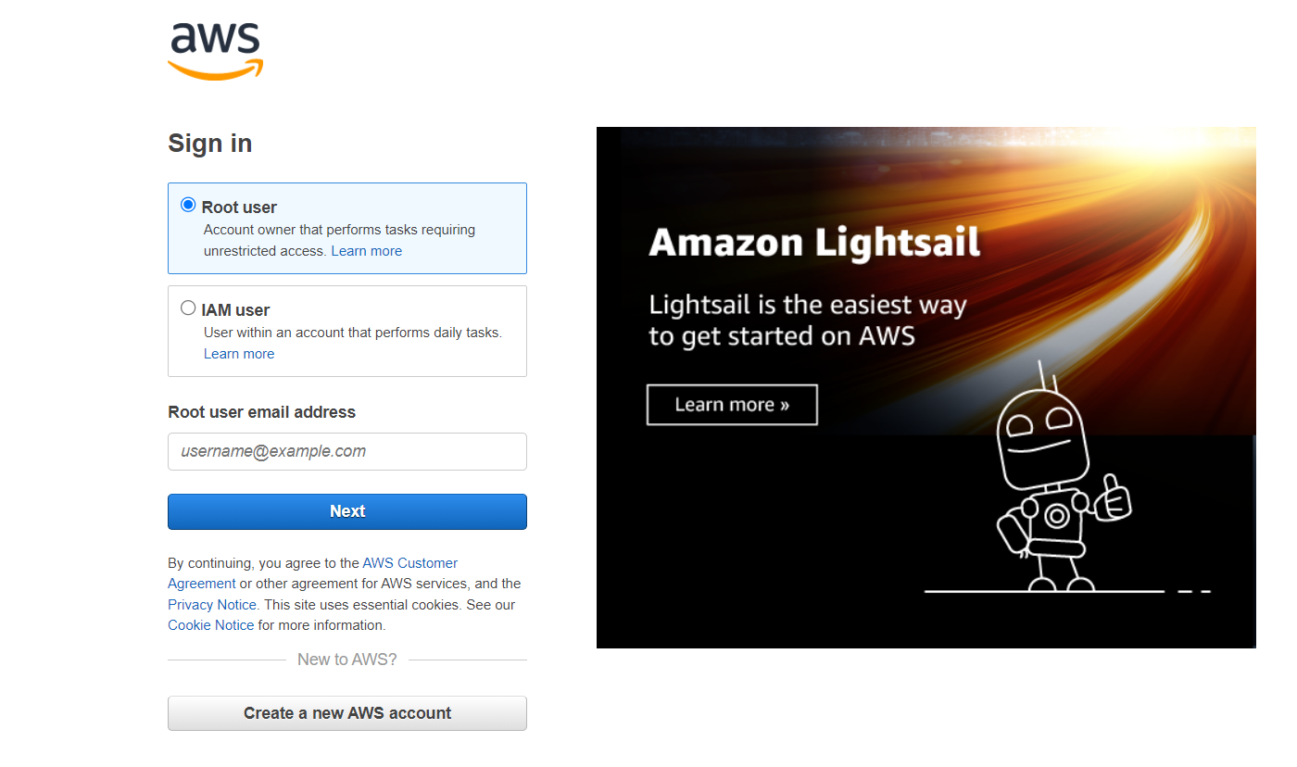

And enter all the details and finally verify your email address

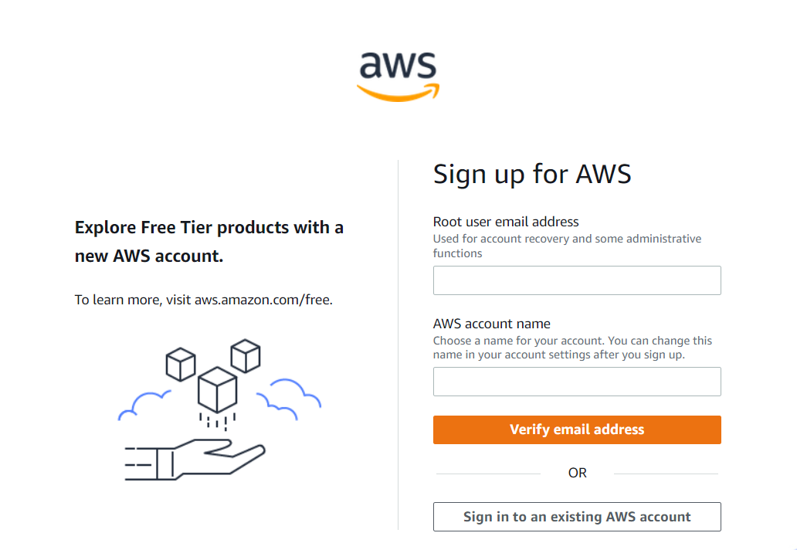

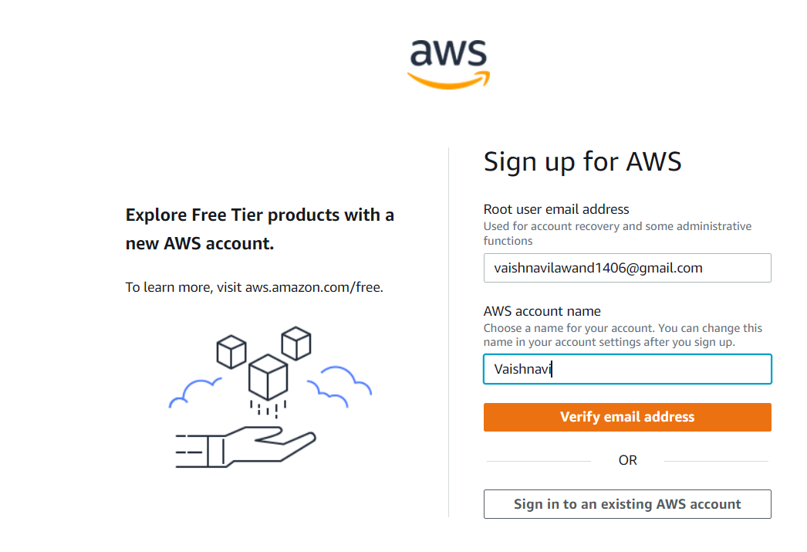

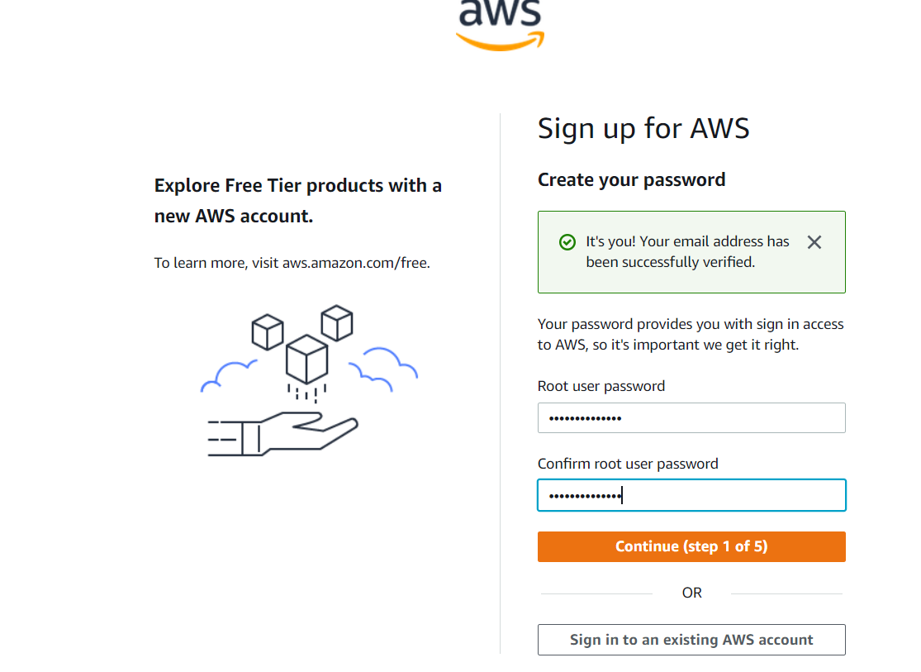

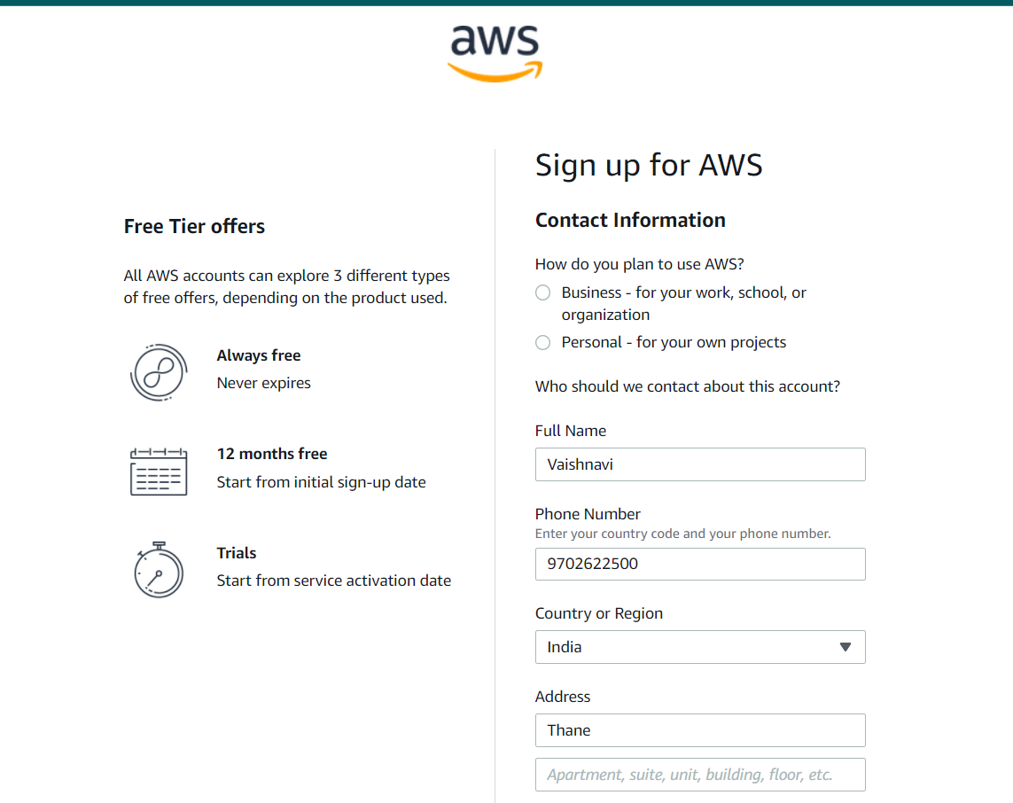

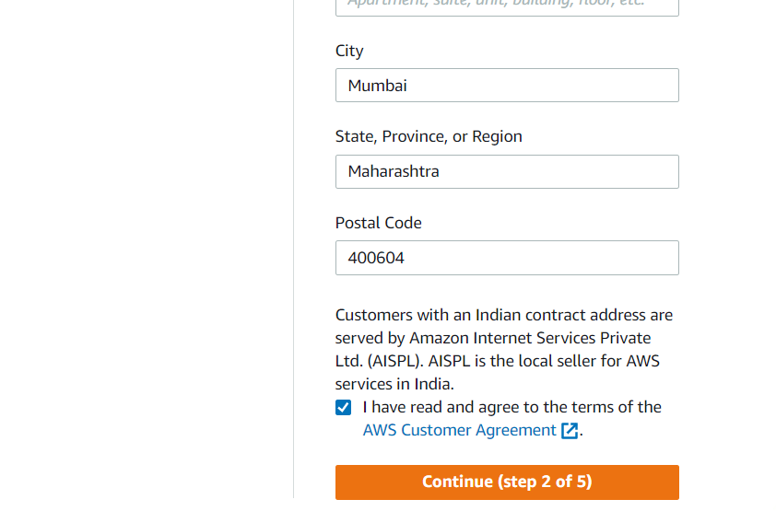

Then login with your email address and password

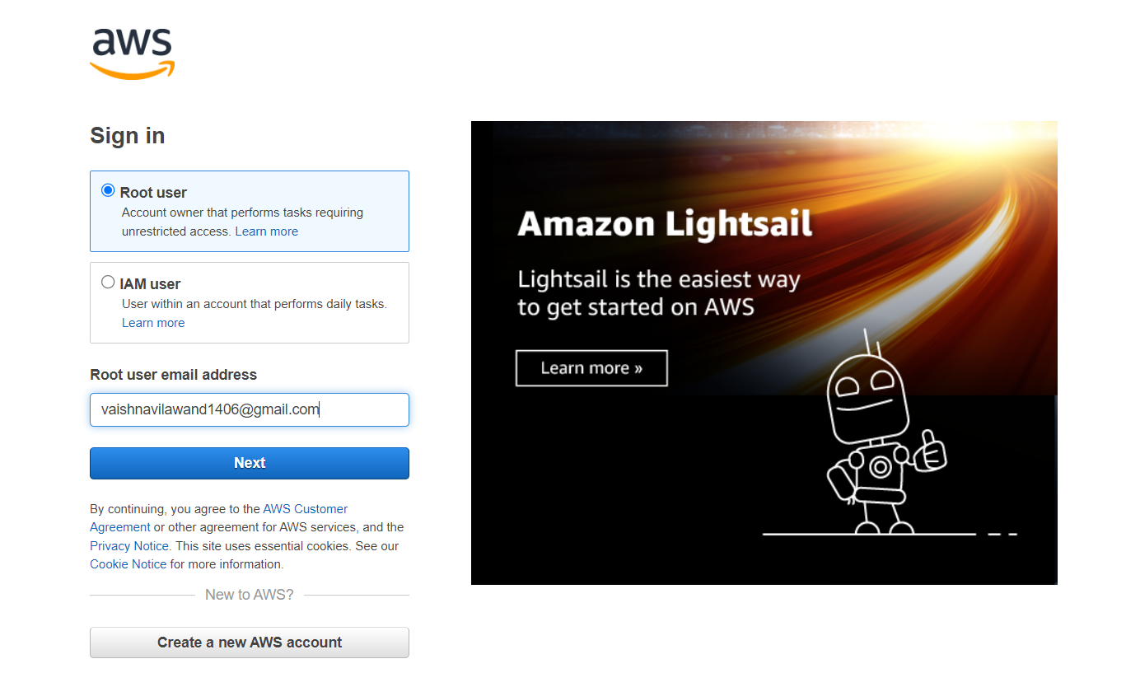

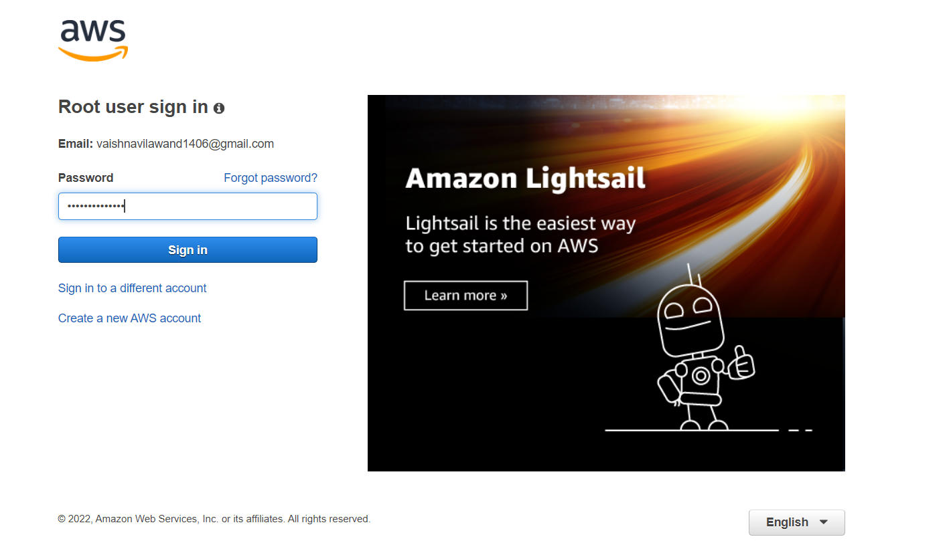

Then go to AWS Management Console

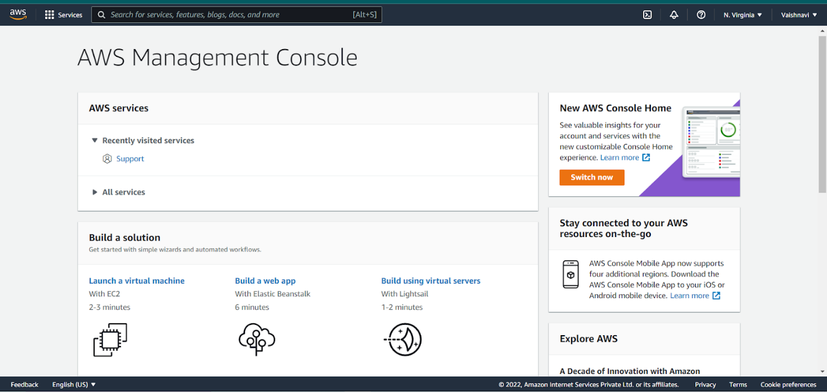

**Practical-6**

1. Study Cloud Security management

Step 1: Open Aws Management Console

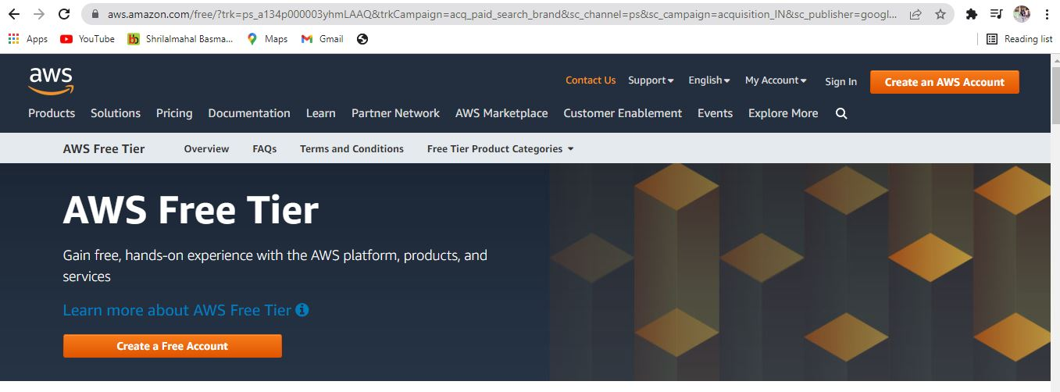

Then go to my account and then select account settings

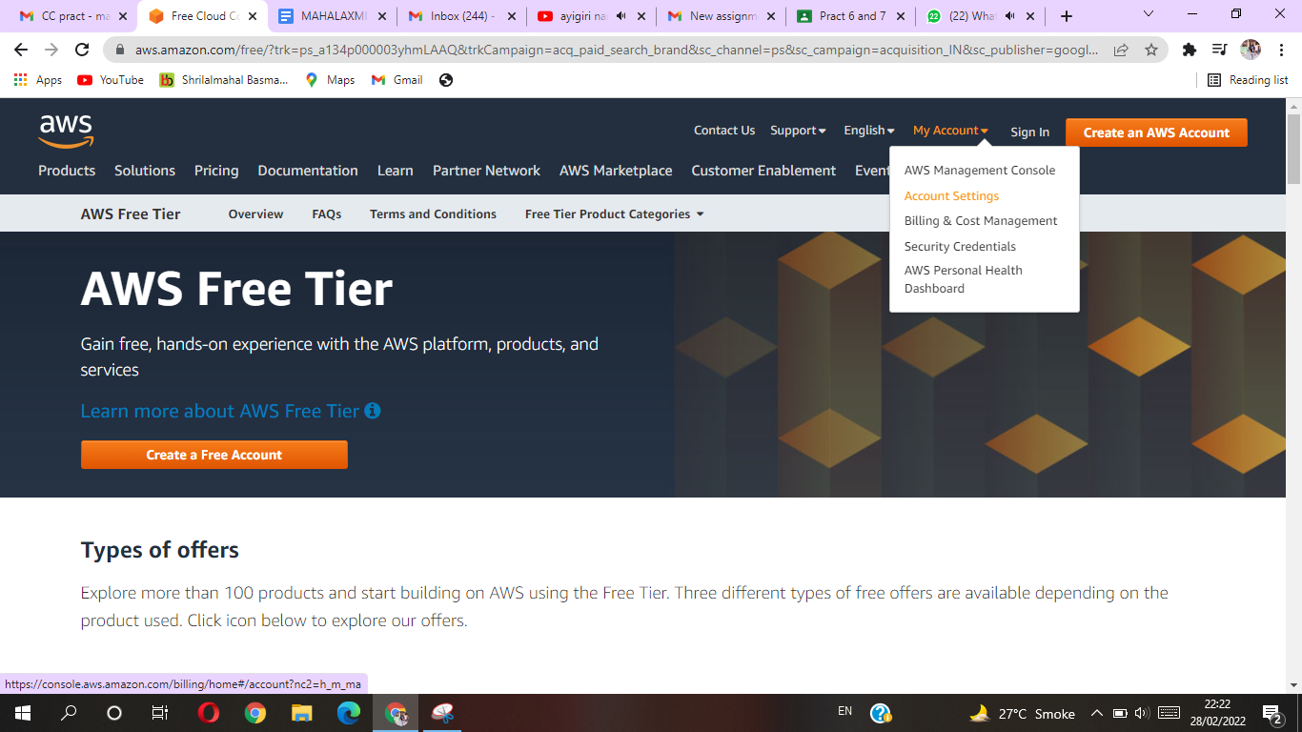

Then create a new AWS account

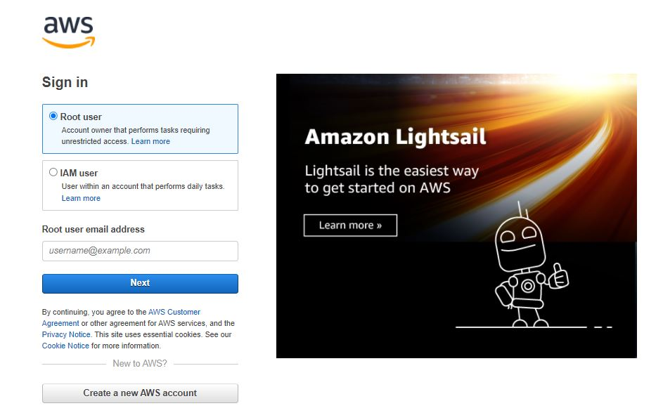

and enter all the details and finally verify your email address

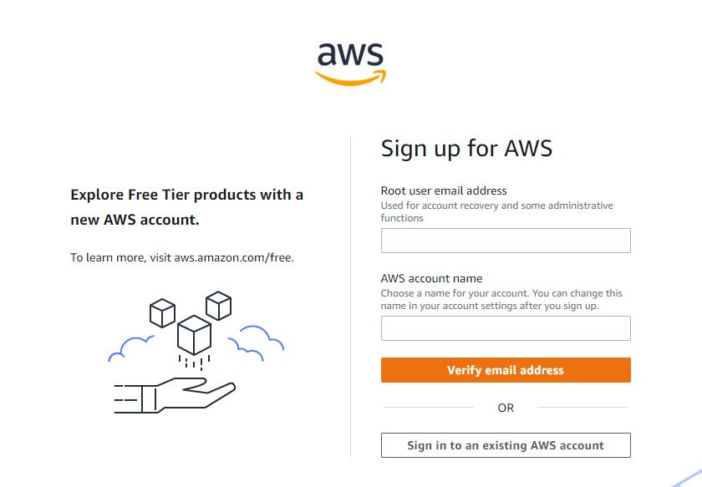

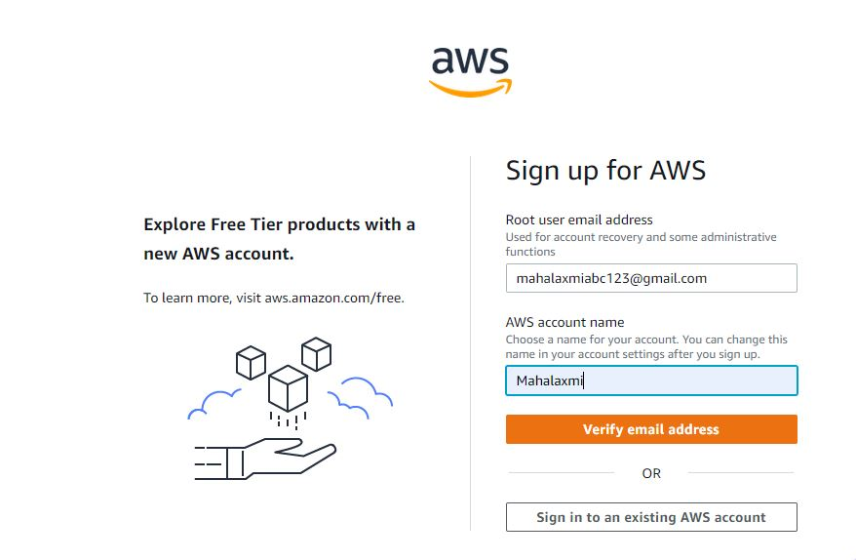

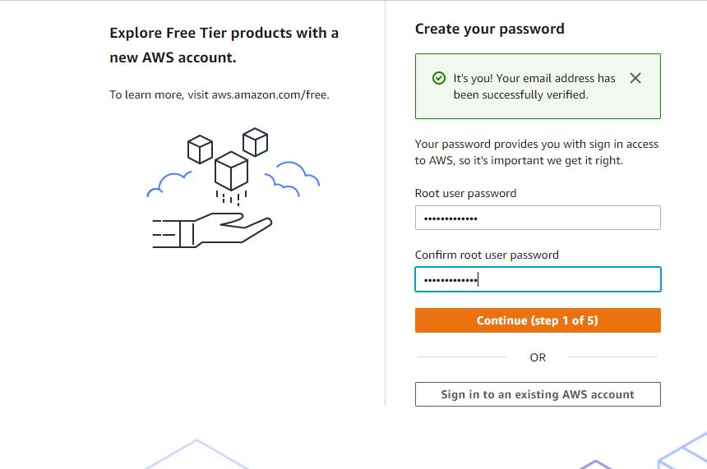

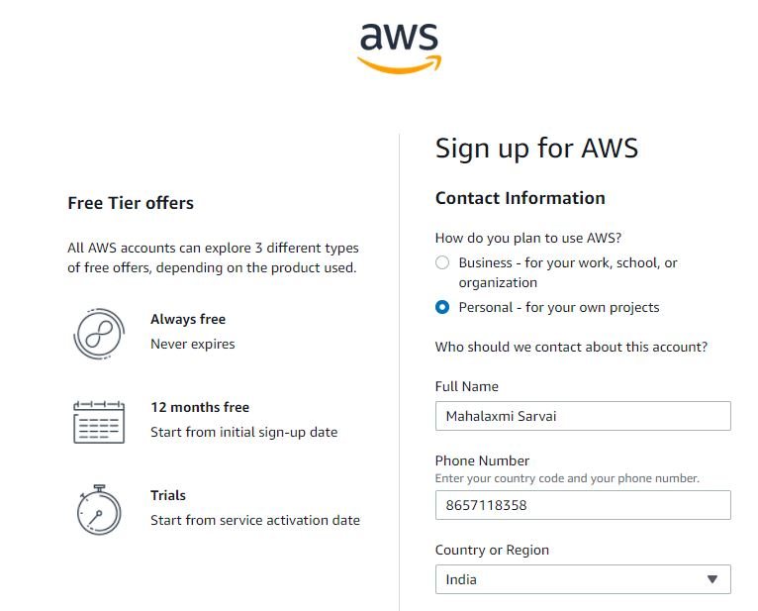

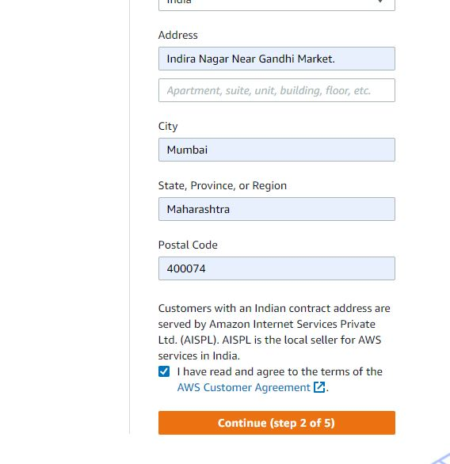

Then login with your email address and password

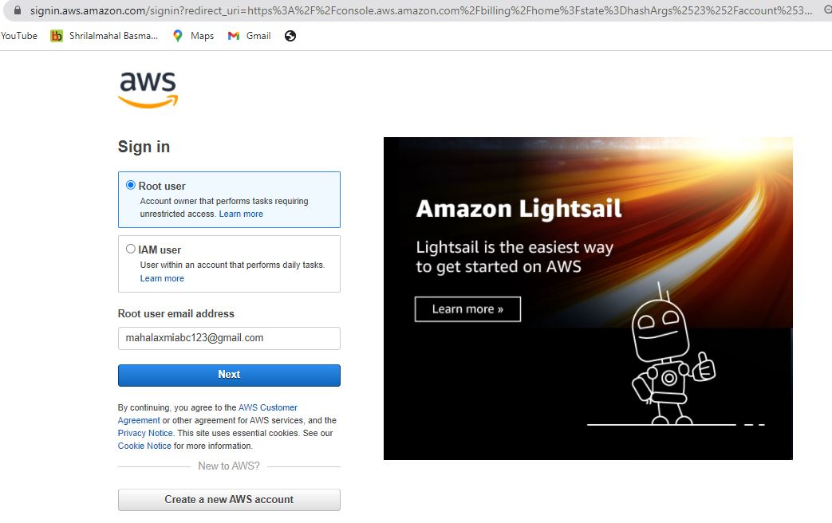

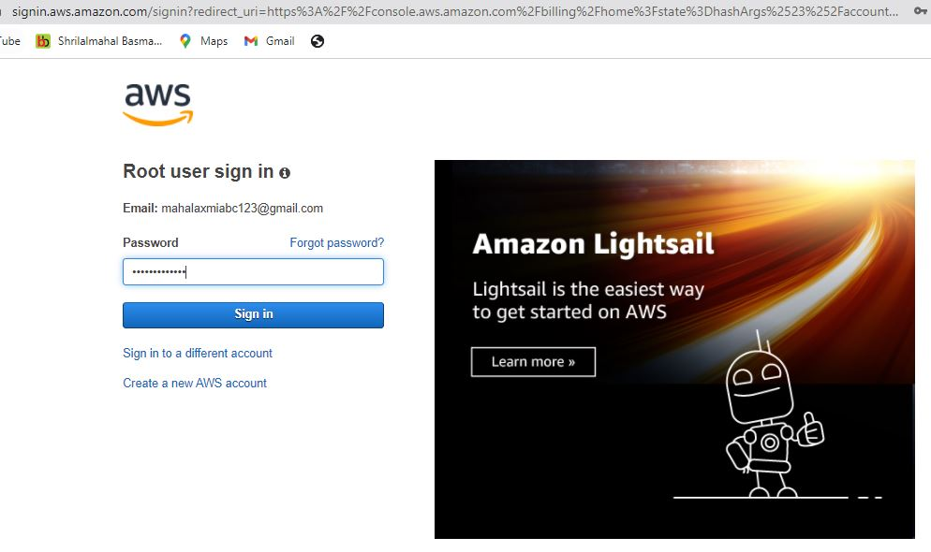

Then go to AWS Management Console

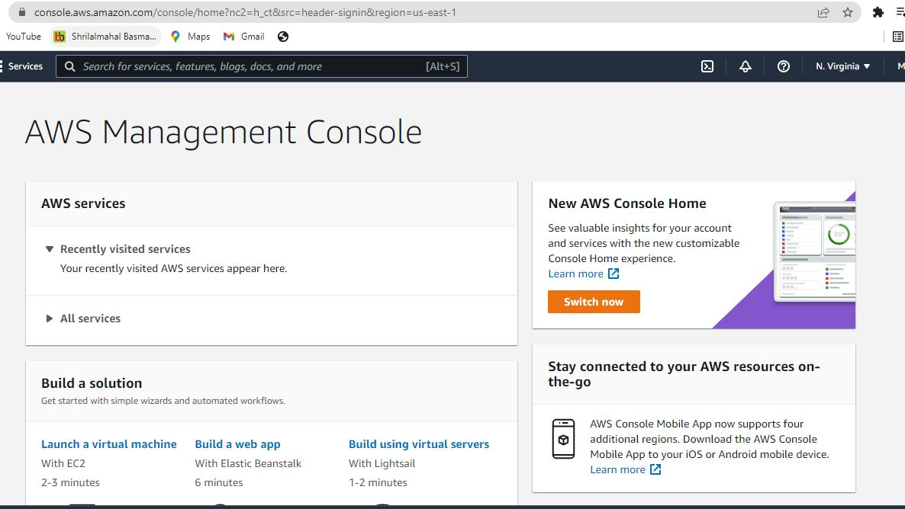

And then select Virtual MFA device and then click continue

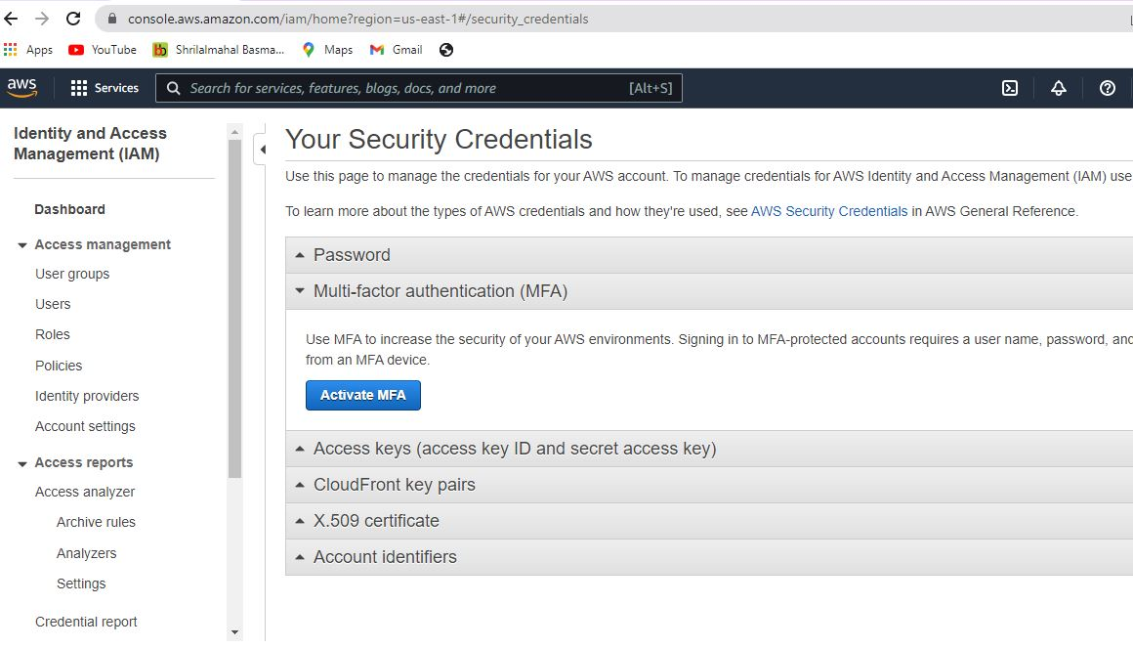

And then scan the QR code

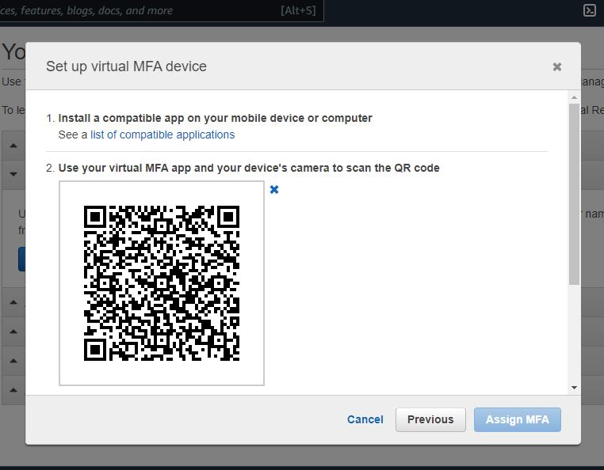

And write MFA code and then click on Assign MFA

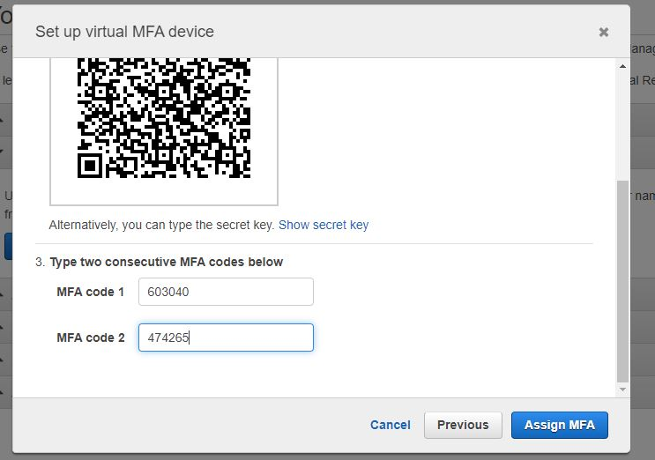

Then sign out and login again

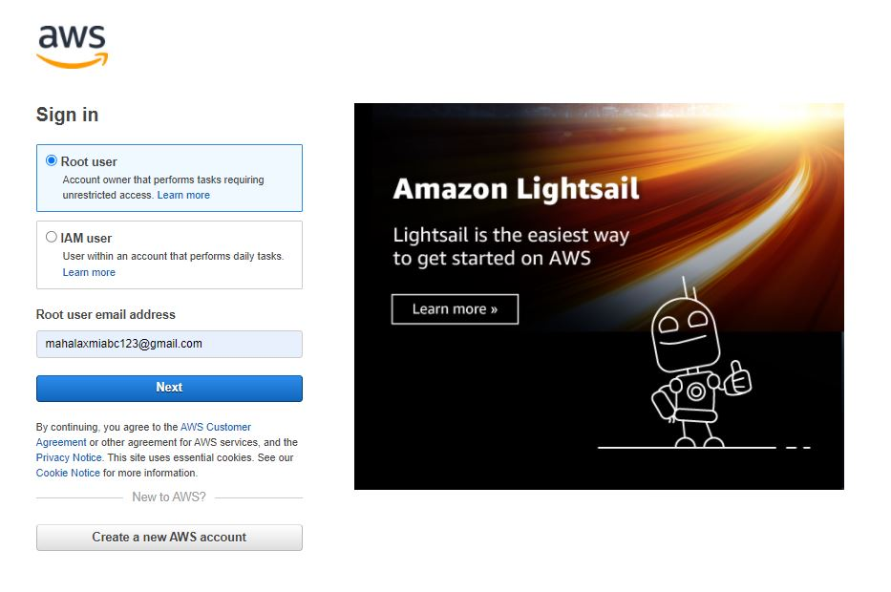

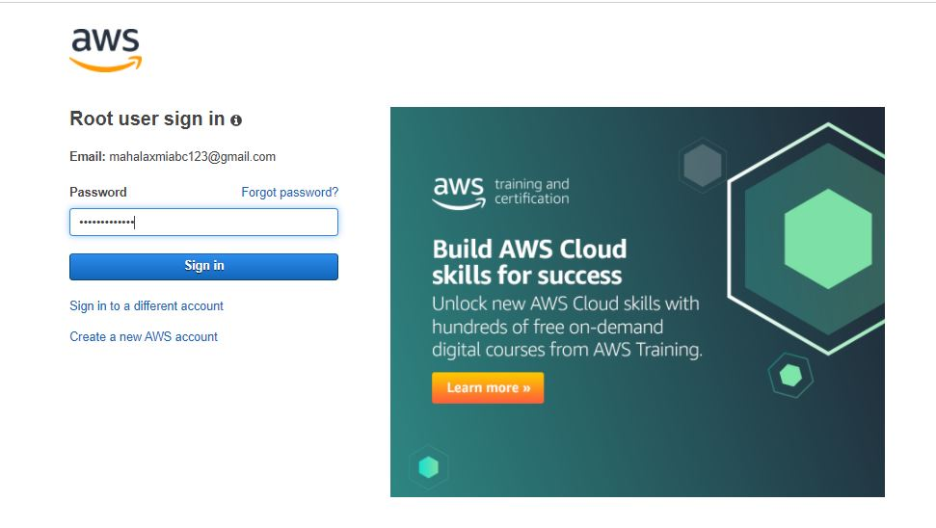

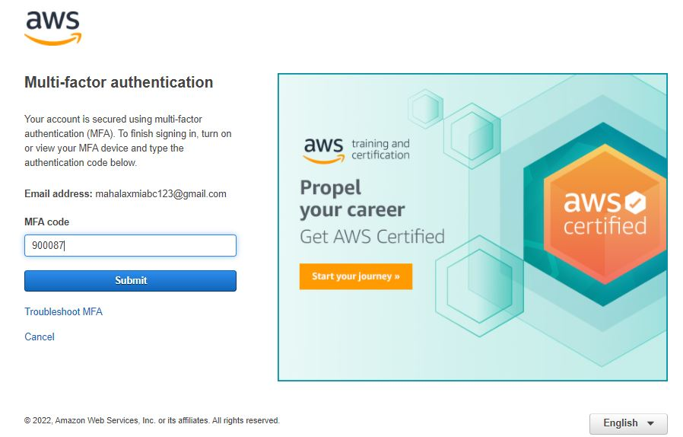

**Practical 7**

1. Write a program for web feed.

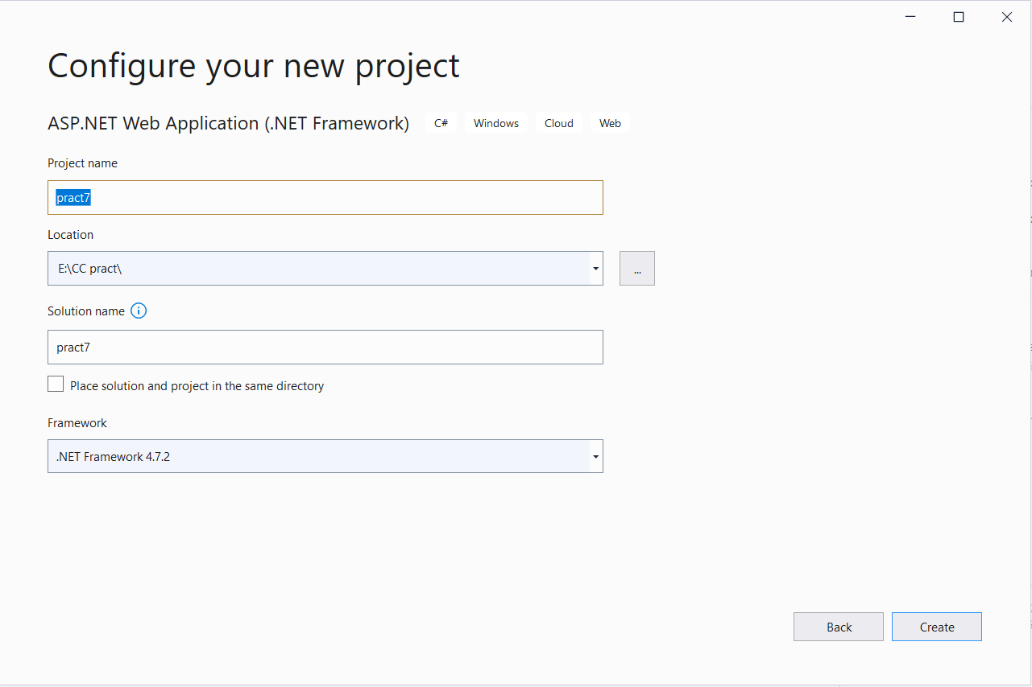Open the visual studio and then select ASP.NET Web Application (.NET Framework)

Then go to solution explorer and right click on project and add

new item and go to web and select web form

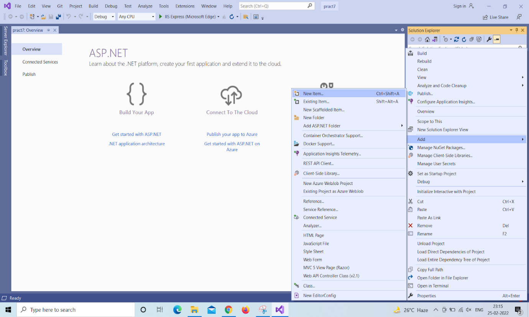

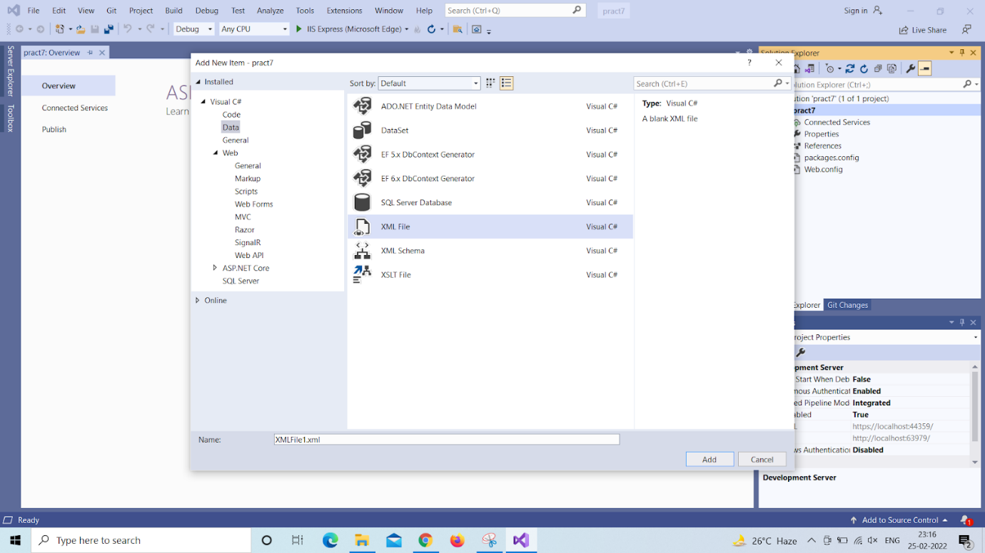

And write the code into xml file

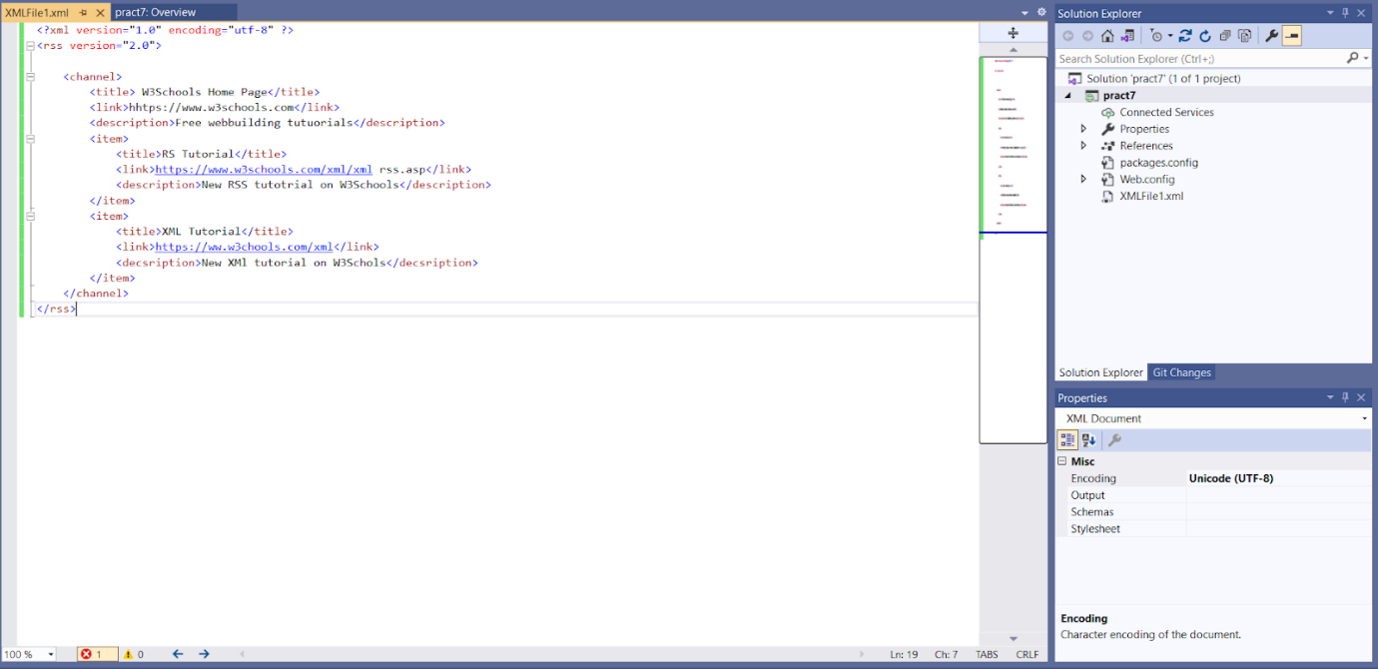

Then go to solution explorer and right click on project and add new item and go to web and select web form

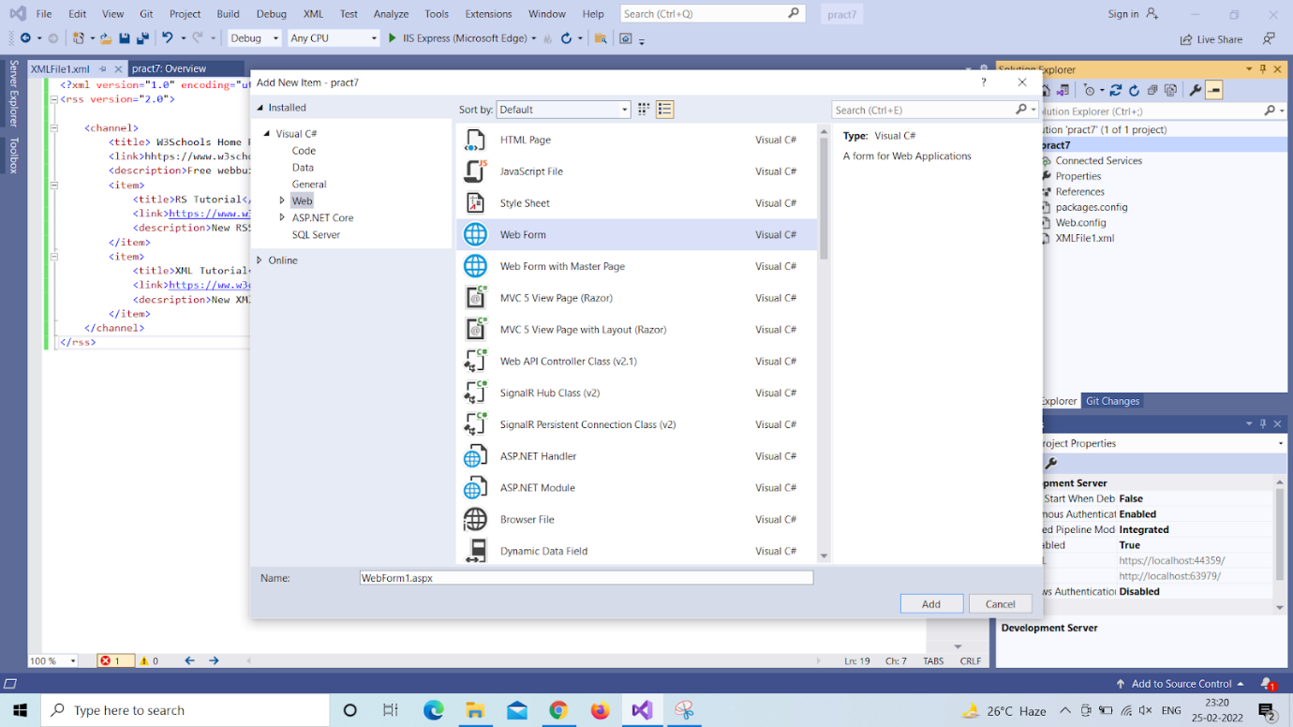

And write the code into web form

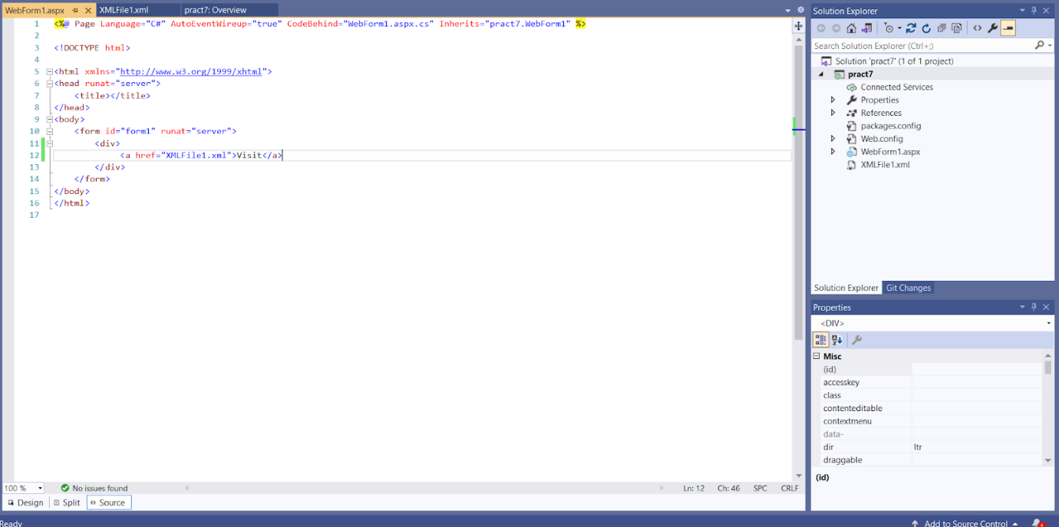



**Practical 8**

1. Study and implementation of Single-Sing-On.

Step 1: Search auth0

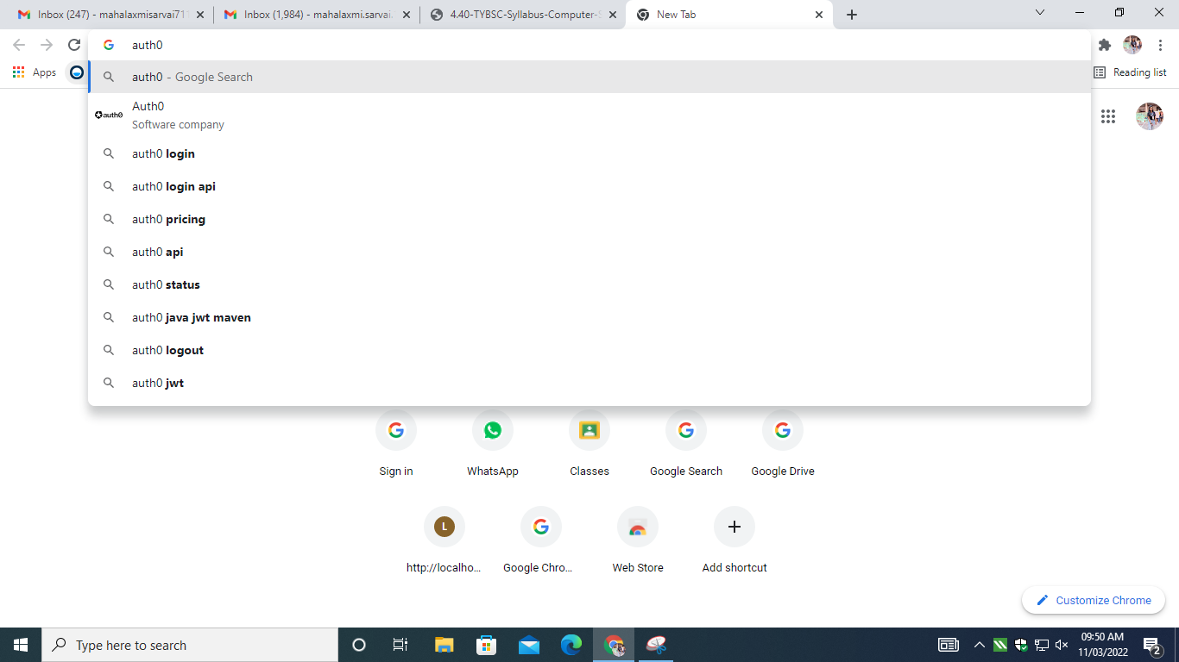

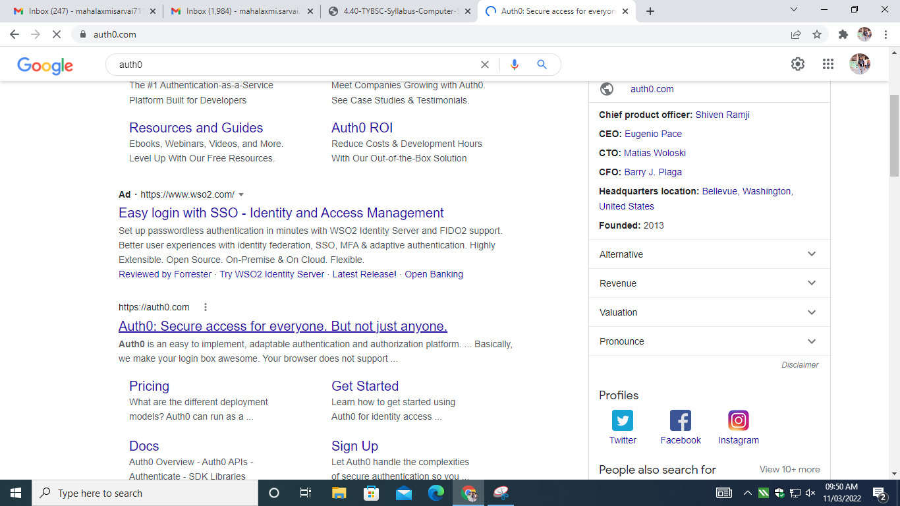

Step 2: Login into auth0

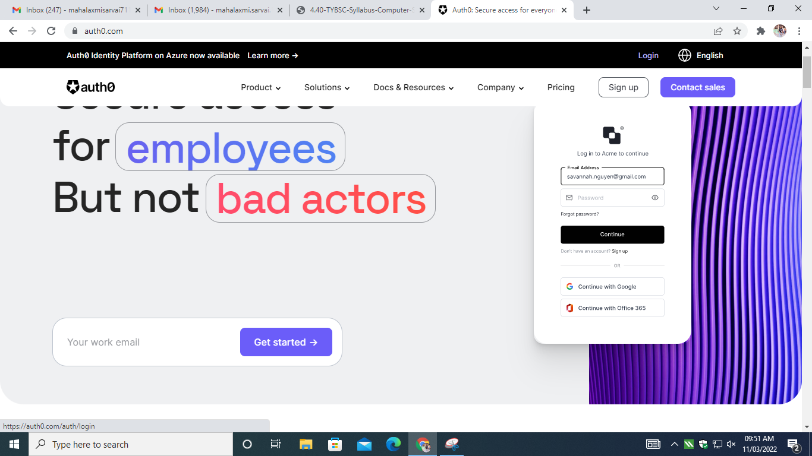

Step 3: Continue with google

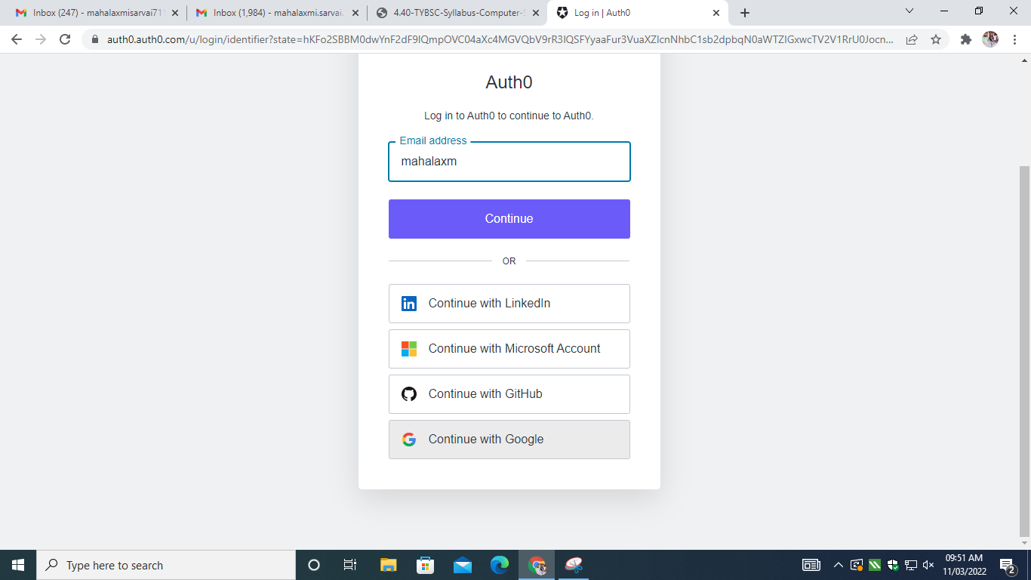

Step 4: Click on Yes Coding

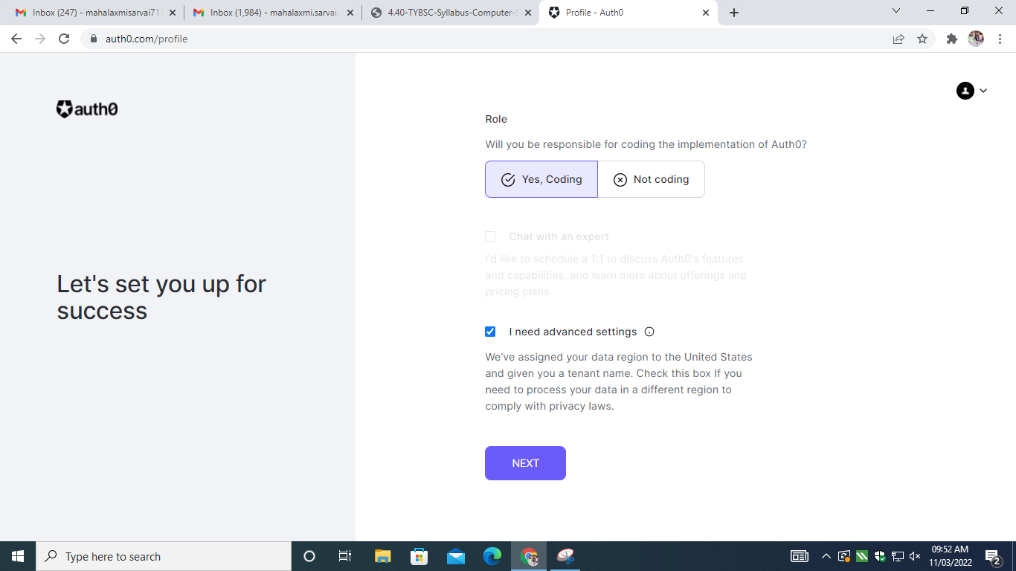

Step 5: Click on create account

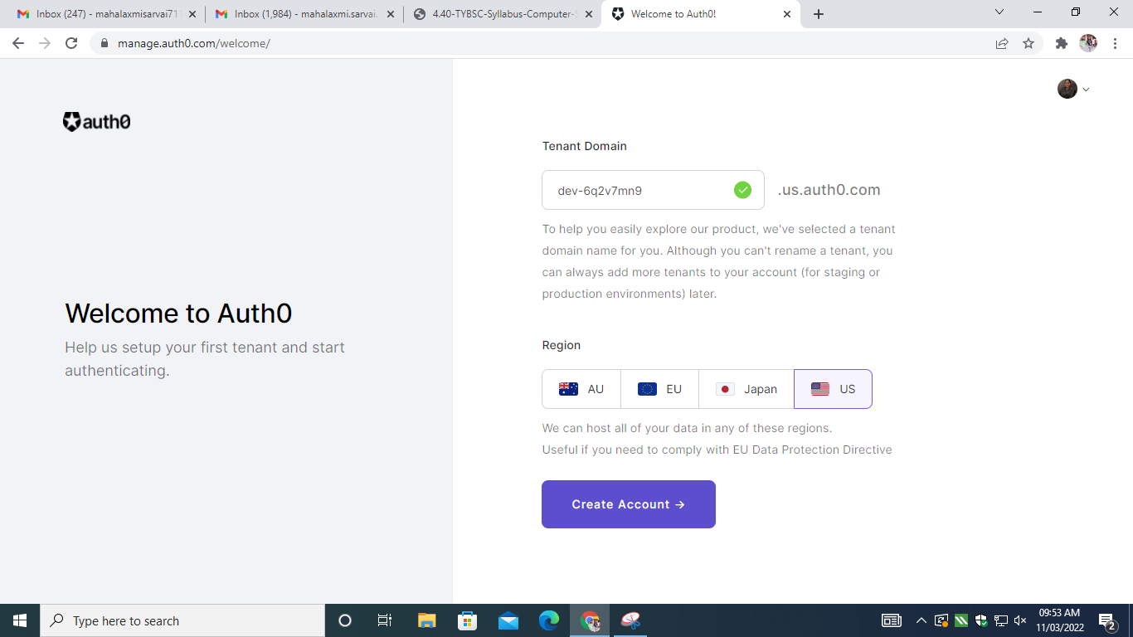

Step 6: This is dashboard of auth0

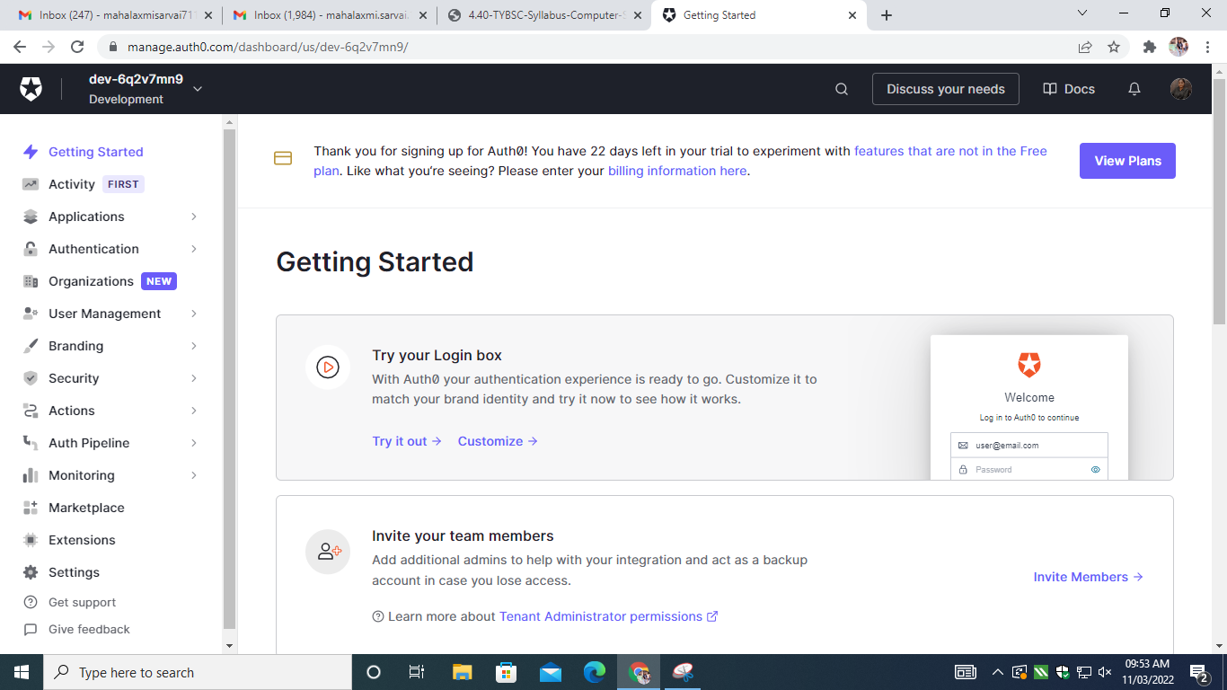

Step 7: Click on authentication->social

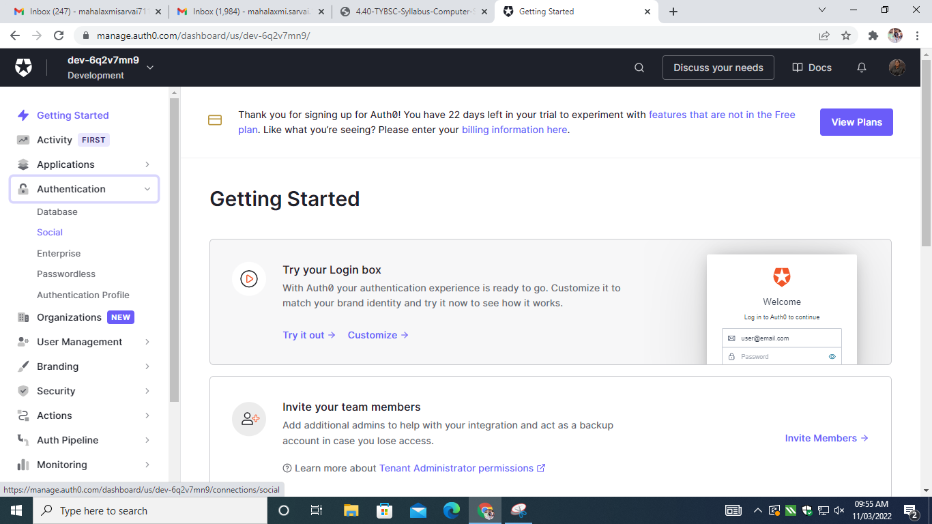

Step 8: Click on create connections

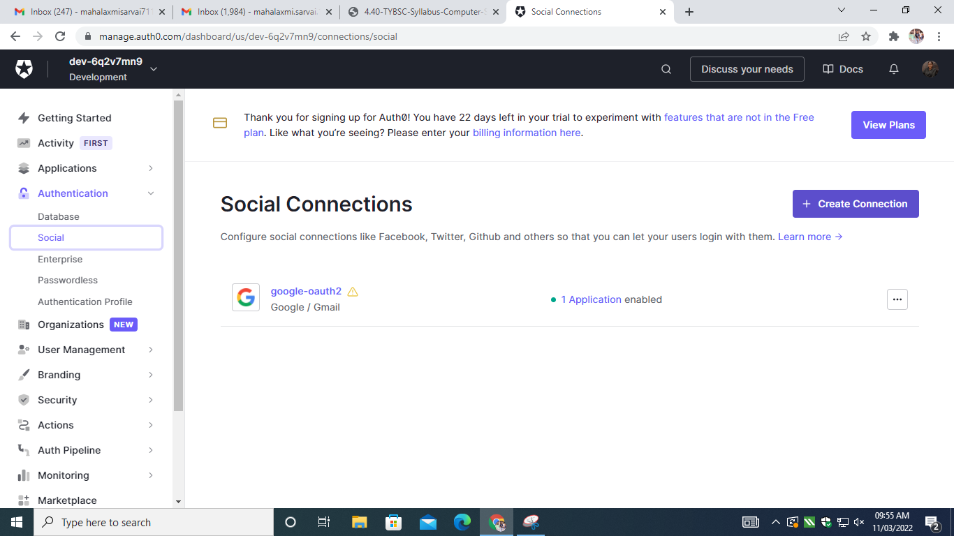

Step 9: we can connect other social accounts

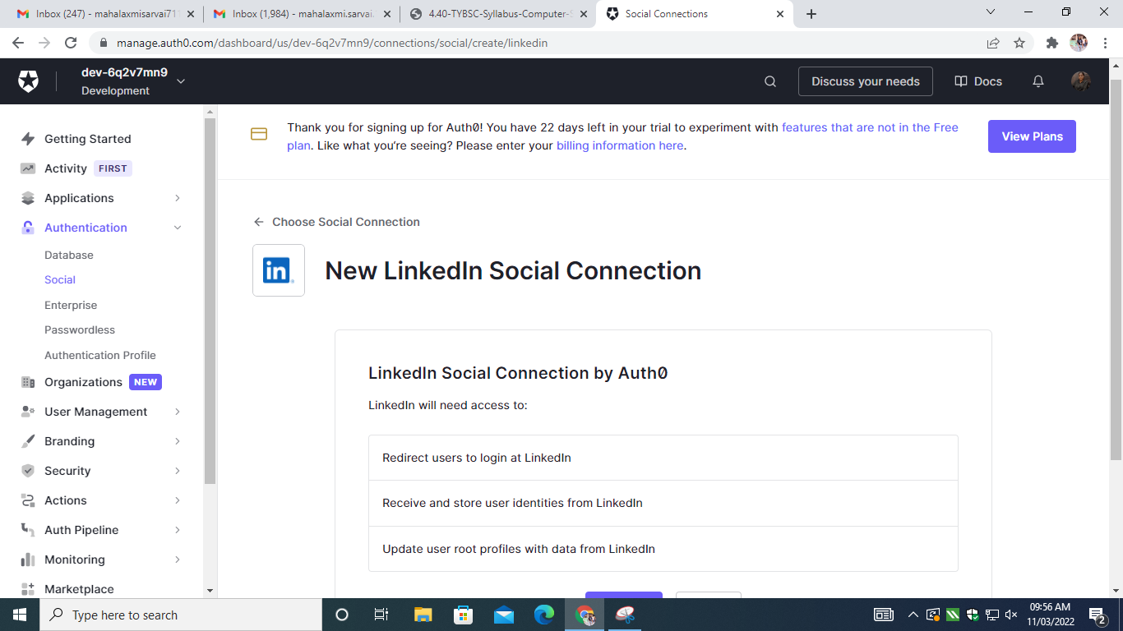

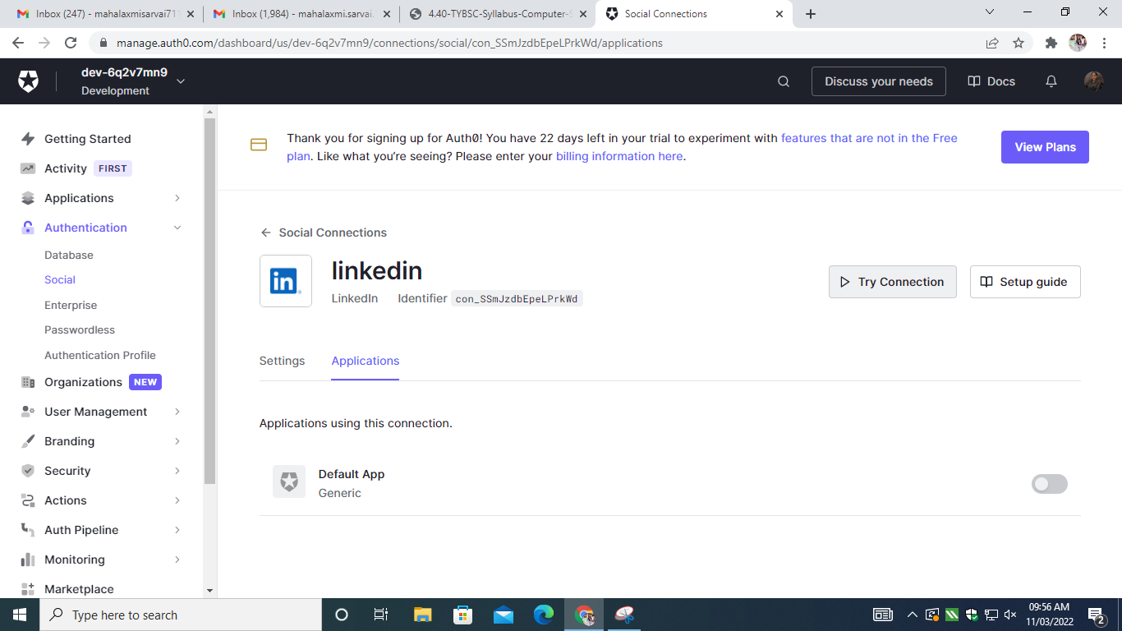

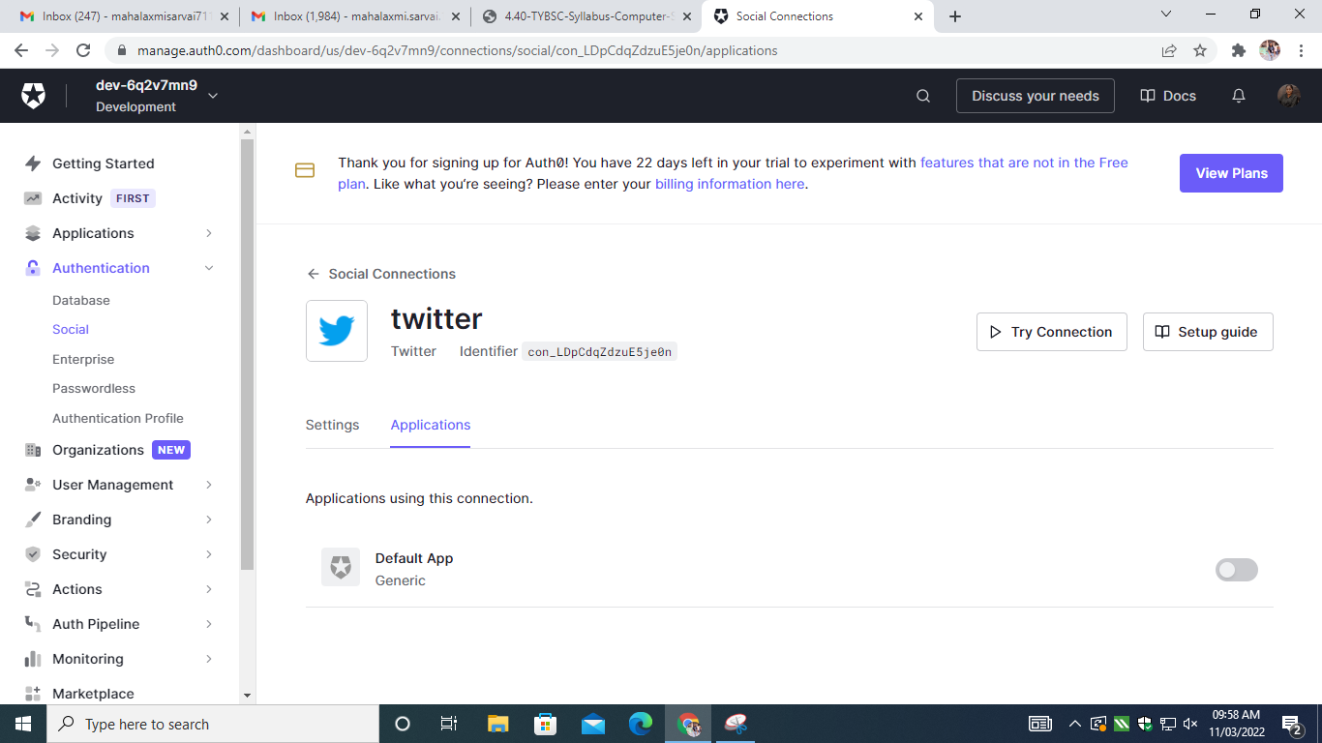

Step 10: click on three dots->try connection

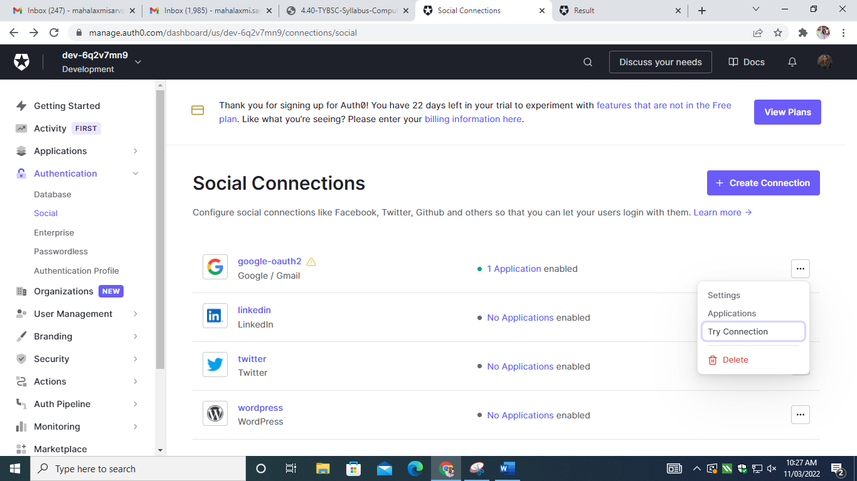

Step 11: we can see authentication details here.

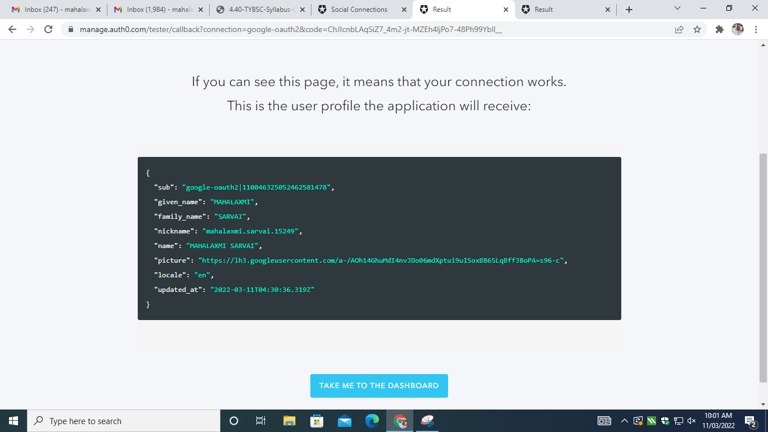

**Practical 9**

1. User Management in Cloud.

Open Google cloud

Start your free trial Login

Enter your details till you get Credit card info page

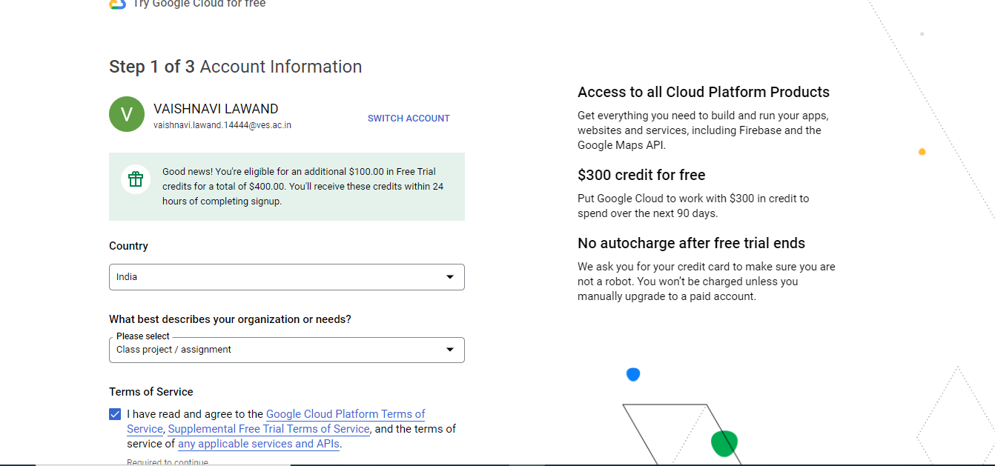

Fill till here

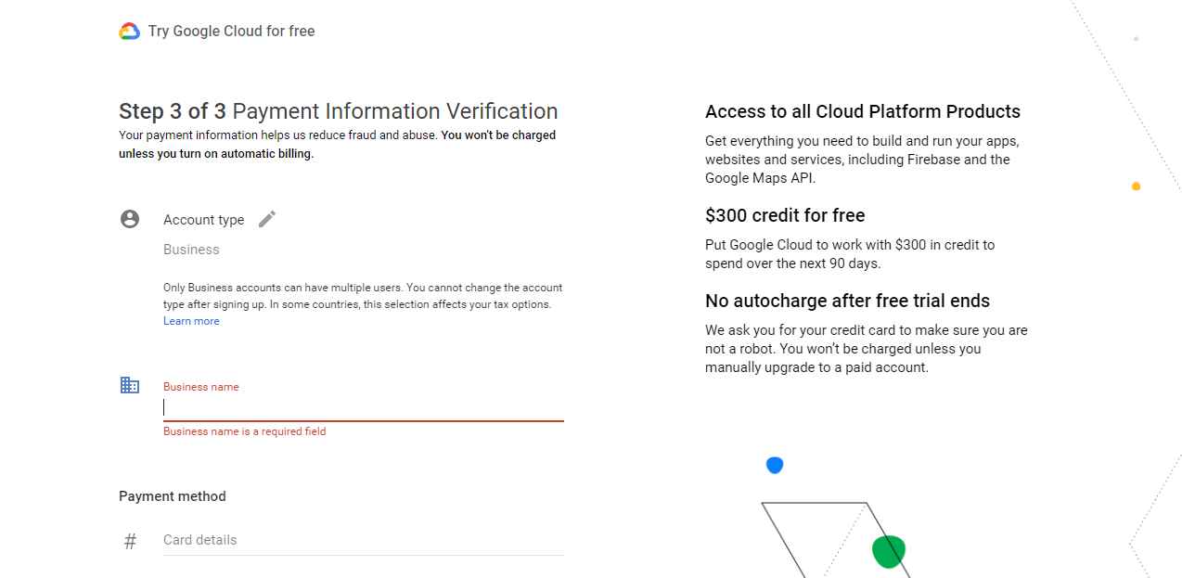

Then close your tab and sign in with your mail

After that you'll get this page

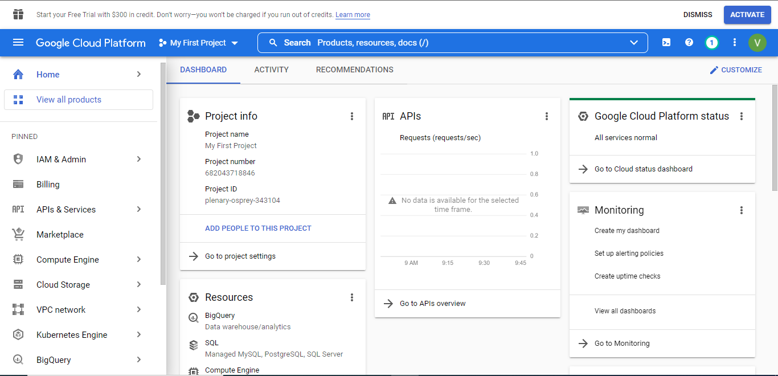

Open the IAM Tab

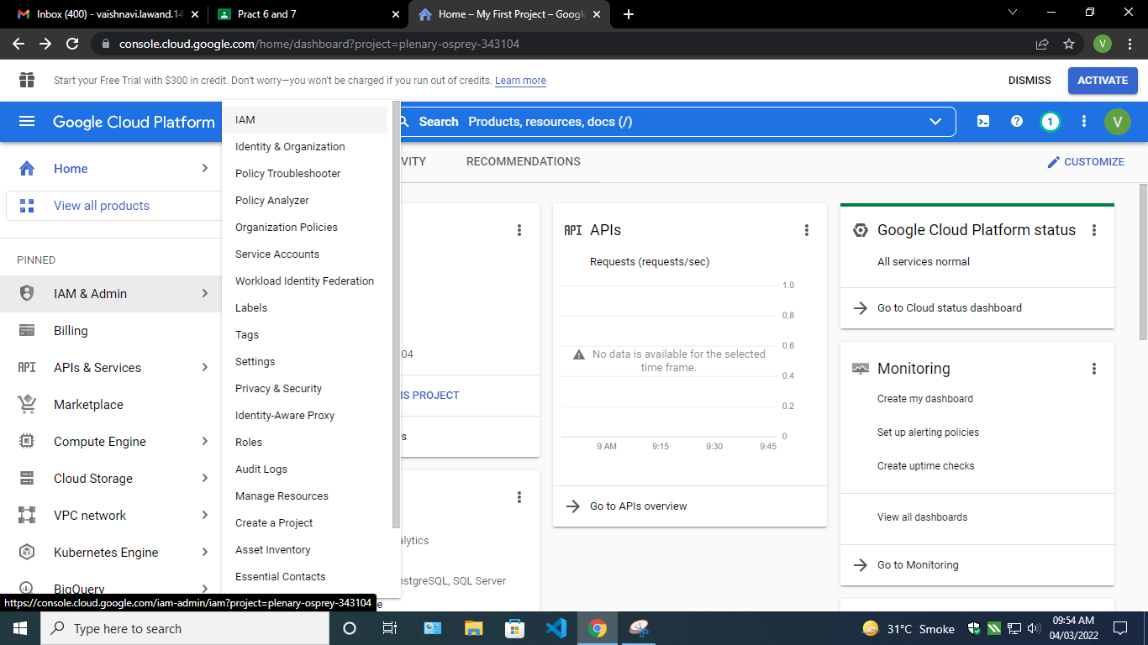

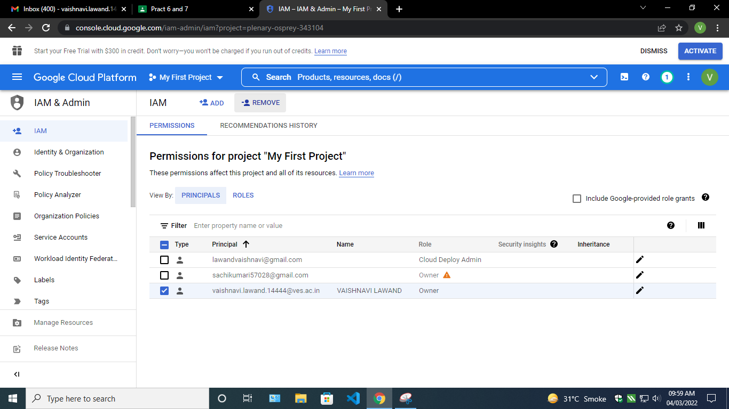

The click on add and add an email

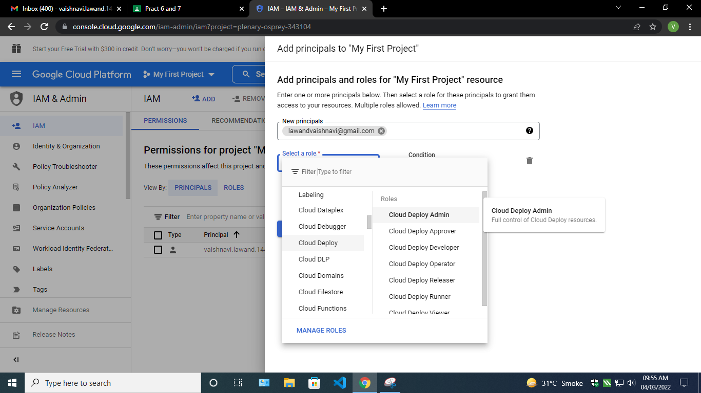

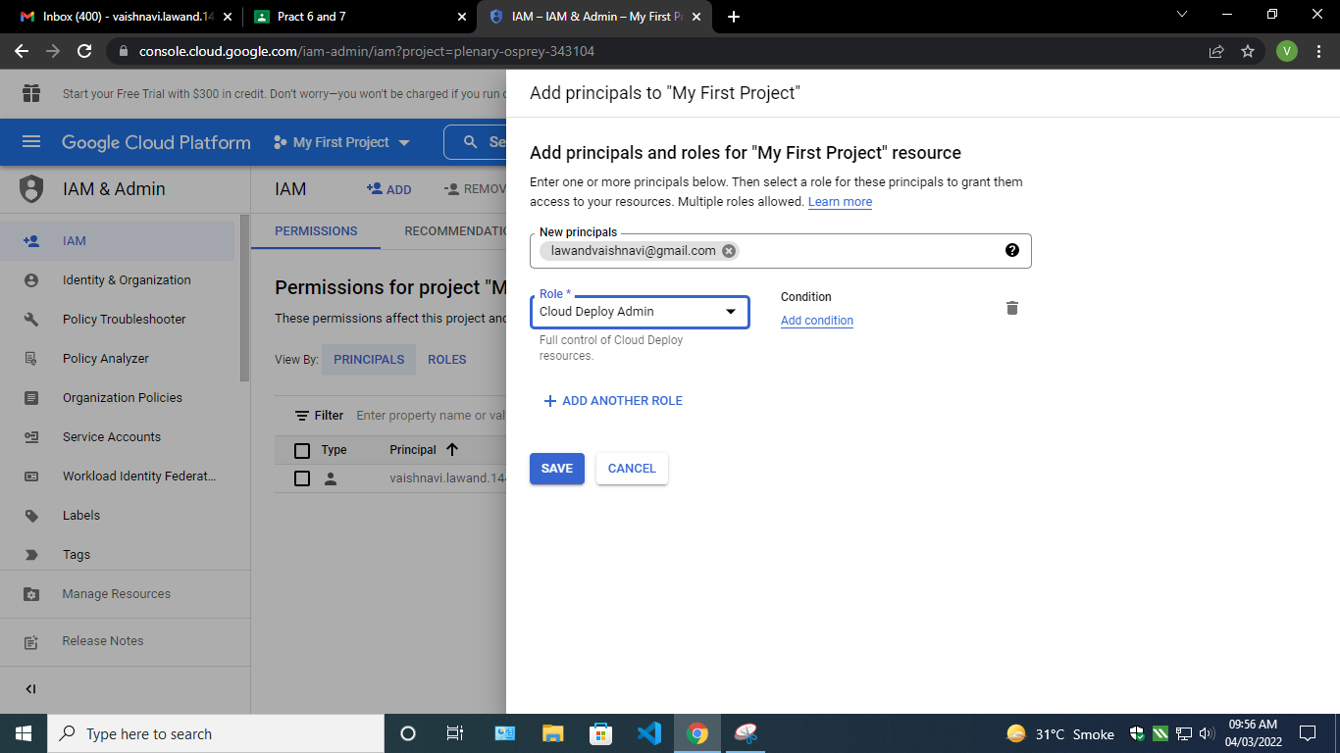

You see the added entry



Got to the added mail and then use the cloud project with your added mail

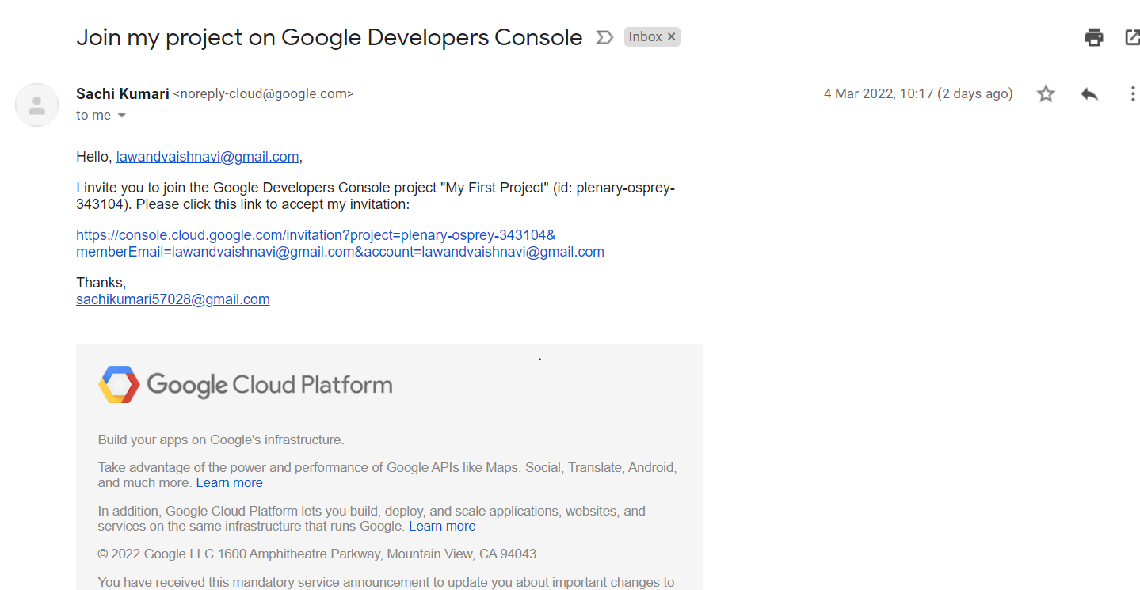

**Practical 10**

10. Case study on Amazon EC2/Microsoft Azure/Google Cloud Platform

Blackboard Optimizes on Amazon EC2, Provides Video

Conferencing to Millions of Teachers and Students

Because of the COVID-19 pandemic and the rapid shift to online

learning in 2020, education technology company Blackboard needed

to scale its capacity to support its virtual classroom solution,

Blackboard Collaborate, which had experienced a 4,800 percent

increase in usage compared to 2019. Chiefly concerned with

providing an interruption-free experience for its users, Blackboard

erred on the side of overprovisioning; in the long term, however, the

company needed a more cost-efficient solution.

Blackboard developed this solution by making smart use of Amazon

Web Services (AWS), including automatic scaling groups and

predictive scaling. The company also optimized its use of Amazon

Elastic Compute Cloud (Amazon EC2)—a web service that provides

secure, resizable compute capacity in the cloud—by switching its

preference to instances powered by AMD EPYC processors, which

offer cost savings over similar instances; and Amazon EC2 Spot

Instances, which enable Blackboard to take advantage of unused

Amazon EC2 capacity and save additional costs. The integrated

solution enabled Blackboard to scale effectively through the surge in

demand, provided the company a 10 percent performance boost, and

reduced the costs of its media processing and batch recording

compute infrastructure by about 28 percent.

Improving Education Technology and Advancing Learning

Using AMD-powered instances and Spot Instances, Blackboard

brought Blackboard Collaborate to millions of students and teachers

worldwide with minimal disruption—and managed its costs in the

process. “AWS was very forthright about where we could cut costs,

and that helped build a strong level of trust,” says Cooksey.

Benefits of AWS

• Supported a 4,800% increase in video conferencing usage

• Improved media processing performance by 10%

• Enabled more precise provisioning by using predictive scaling

• Saved ~28% on total media processing and batch recording costs